

**Cairo University**

**Faculty of Engineering**

**Electronics & Communication Department**

**ELC3050 Project**

**Design and Analysis of a 2-Element Probe-Fed Microstrip Patch Antenna Operating at 20 GHz**

**Under supervision of Dr Islam Eshra**

|  |  |
| --- | --- |
| **Name** | **ID** |
| **يوسف خالد عمر محمود** | **9220984** |
| **مصطفى أحمد حسني محمود درويش** | **9220832** |
| **مصطفى فتحي محمد حسن عسكر** | **9220844** |
| **يوسف اشرف محمد** | **9220972** |
| **عمر احمد رجب** | **9220513** |
| **عمر ايمن امين** | **9220528** |

Table of Contents

Table of Figures 3

1. Introduction and Problem Description 5

Verification Against Another Source 5

Benchmark Description 7

2. Design Procedure 12

Patch: 12

Substrate: 13

EM calculator: 16

Design of single patch 17

S11: 19

Zin: 22

Radiation patterns 24

Gain: 26

Gain Performance of a Single Patch Antenna 27

Design of Two Patches: 28

S-Parameters: 29

Mutual Coupling vs Element Spacing: 31

Zin: 32

Radiation patterns 33

Gain: 35

Bandwidth Enhancement Techniques: 38

3. Results and Discussion 45

3.1 Return Loss (S11) 45

3.2 Mutual Coupling (S21) 45

3.3 Smith Chart Analysis 45

3.4 Radiation Patterns 45

3.5 Gain and Efficiency 46

4. Final Design Layout 46

5. Conclusion 46

6. Refrences: 47

Table of Figures

Figure 1: dipole antenna designed for verification 6

Figure 2: S11 for dipole antenna for verification 8

Figure 3: Zin for dipole antenna for verification 9

Figure 4: Gain 2D for dipole antenna for verification 9

Figure 5: Gain 3D for dipole antenna for verification 10

Figure 6 RT-duroid 5870 - 5880 Data Sheet 12

Figure 7 EM calculator results 15

Figure 8 L,W S11 sweaping 15

Figure 9: antenna with probe feeding model 16

Figure 10: 3D patch antenna design 16

Figure 11: bottom view of patch antenna 17

Figure 12: side view of patch antenna 17

Figure 13: S11 for single Patch antenna 18

Figure 14: smith chart for single Patch 19

Figure 15: Bandwidth where S11<-10 dB 19

Figure 16: VSWR = 1.421 at 20 GHz for single patch antenna 20

Figure 17 Xfeed for single patch antenna 21

Figure 18 Zin for single Patch antenna at 20GHz 21

Figure 19: Yfeed for single patch antenna 22

Figure 20: Electric Field Radiation for single patch antenna 23

Figure 21: magnetic field radiation for single patch antenna 23

Figure 22: Co-polarization and cross-polarization patterns in the E- and H-planes. 24

Figure 23: Gain 3D for single patch antenna 25

Figure 24: Gain 2D for single patch antenna 25

Figure 25: Two Patch antenna array 27

Figure 26: Two Patch side view 27

Figure 27: S11 for Two patches 28

Figure 28: VSWR for first Patch 28

Figure 29: VSWR for second Patch 29

Figure 30: S21 Vs Frequency 29

Figure 31: S21 sweep Vs frequency by changing dp 30

Figure 32: S21 Vs Distance between two patches 30

Figure 33: Zin for two Patches at 20 GHz 31

Figure 34: Electric field radiation of two patches 32

Figure 35: magnetic pattern for two patches 32

Figure 36: Co-polarization and cross-polarization patterns in the E- and H-planes. 33

Figure 37: Gain 3D for two patches 34

Figure 38: Gain 2D for two patches 34

Figure 39: Gain Vs Frequency 36

Figure 40: Radiation Efficiency Vs Frequency 36

Figure 41: T-Section transmission line 37

Figure 42: S11 after adding T-section TL showing enhancement in BW 38

Figure 43: Zin after adding T-section transmission line 38

Figure 44: VSWR after adding feeding network 39

Figure 45: magnetic Field Radiation of 2 antenna design probe feed 40

Figure 46: Electric Field Radiation of 2 antenna design probe feed 40

Figure 47: Co-polarization and cross-polarization patterns in the E- and H-planes for 2 antenna array probe feed 41

Figure 48: gain 2D for 2 antenna array probe feed 41

Figure 49: Gain 3D for 2 antenna array probe feed 42

Figure 50: table of final results 43

# 1. Introduction and Problem Description

This project involves the design of a 2-element probe-fed microstrip patch antenna operating at 20 GHz. The goal is to achieve an S11 less than -10 dB at the operating frequency while optimizing performance in terms of bandwidth, gain, and radiation efficiency. A comprehensive analysis of the antenna's mutual coupling and gain vs. element spacing is also included.

# Verification Against Another Source

We’re going to simulate a dipole with the design in figure 9.9 in refrence [1] with HFSS.

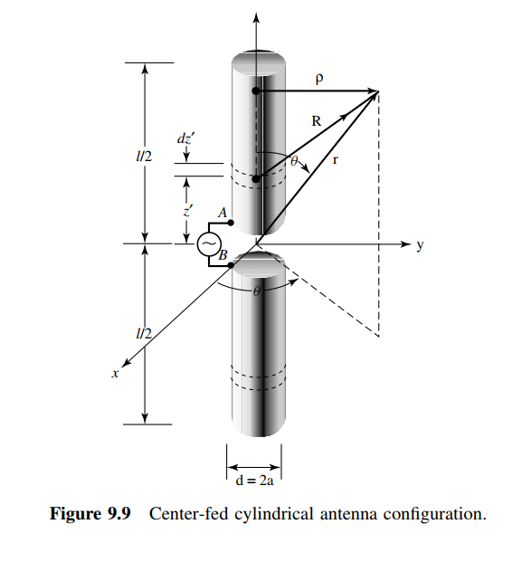

With values that’s applied in figure 1:

|  |  |  |  |
| --- | --- | --- | --- |
| Name | Unit | "Evaluated Value" | Description |
| dl | mm | 139.5mm | Antenna length |
| rdi | mm | 0.2625mm | Antenna radius |
| gap_L | mm | 1mm | Gap length |

Figure 1: dipole antenna designed for verification

## Benchmark Description

* A dipole antenna is a standard reference in antenna theory, with well-documented characteristics such as impedance, radiation pattern, and gain.
* It is widely used as a baseline for verifying simulation accuracy and comparing performance metrics.

**Simulation Setup**

1. **Design Parameters**:
   * Length of the dipole: L= is the wavelength at the operating frequency.
   * Material: Mention the conductor used (copper or PEC).
2. **Simulation Environment**:
   * Define the simulation parameters, such as mesh size, boundary conditions, and excitation type (e.g., lumped port or wave port).
3. **Performance Metrics Evaluated**:
   * Return Loss (S11).
   * Radiation patterns in E-plane and H-plane.
   * Gain and efficiency.

**Equations Controlling Dipole Antenna**

1. **Directivity**:
2. **Radiation Pattern**:
   * E-plane pattern: for .
   * H-plane pattern: for
3. **Input Impedance**:
4. **Gain**:

where is the efficiency of the antenna.

**Results Comparison**

We are going to use Table 9.1 in refrence [1] to verfy. According to it I’m expecting Rin=67Ω

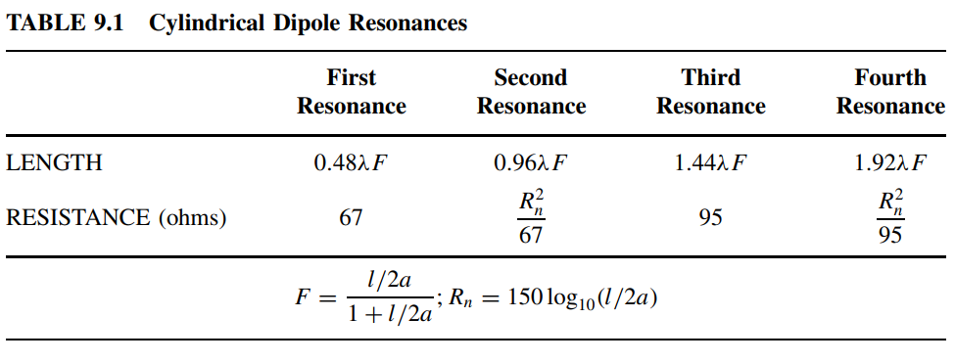

Figure 2: S11 for dipole antenna for verification

Figure 3: Zin for dipole antenna for verification

Figure 4: Gain 2D for dipole antenna for verification

Figure 5: Gain 3D for dipole antenna for verification

**Conclusion**

* The dipole antenna serves as a reliable reference for verifying the EM simulation tool.
* imulated results of the dipole antenna matches theoretical expectations (S11 plot, radiation pattern, and gain).
* The Rin is 68.63 which is approximately equal to the theotical value in Table 9.1.

***So the EM tool HFSS is verified***

# 2. Design Procedure

The design started with the selection of the substrate material R04003C with a dielectric constant of 3.55. Initial dimensions were calculated using standard formulas for microstrip patch antennas, considering a substrate thickness of 0.406 mm. An online calculator was used to determine the initial patch dimensions, which were fine-tuned through simulation sweeps for optimal S11 performance.

A single patch antenna was first designed and analyzed to establish baseline performance metrics. Subsequently, a 2-element array was constructed with varying patch separation distances (dp) to study mutual coupling. A matching network was designed for probe feeding to further optimize the design.

At first, we started with the following mathematical modelling for our design then we tuned and swept parameters to achieve required specs.

## Patch:

The resonant frequency of a rectangular microstrip patch antenna can be calculated using:[5]

where:

* : Speed of light in free space (  )
* : Effective length of the patch
* : Effective dielectric constant of the substrate.

Effective Length:

where:

## Substrate:

Effective dielectric constant:

where:

* : Relative permittivity of the substrate

We used RO4003C dielectric with [4]

* : Height of the substrate
* : Width of the patch.
* A screenshot of a computer

  Description automatically generated

Figure 6 RT-duroid 5870 - 5880 Data Sheet

**2. Bandwidth Enhancement Analysis**

Bandwidth () is related to the quality factor () by:

Technique used to improve bandwidth:

* **Impedance Matching**: Adding a matching network to reduce reflections.
  + Use Zin and Z0 to compute matching network:

**3. Input Impedance**

The input impedance at the feed point is given by:

​

where ​ and ​ are resistance and reactance components derived from field distributions.

**4. Radiation Pattern**

The far-field electric field components can be approximated as:

where:

* ​: Wave number
* : Distance to observation point
* : Intrinsic impedance of the medium.

**5. Gain and Efficiency**

Gain () and radiation efficiency ( ​) are related:

where is the directivity.

Efficiency:

​​

# EM calculator:

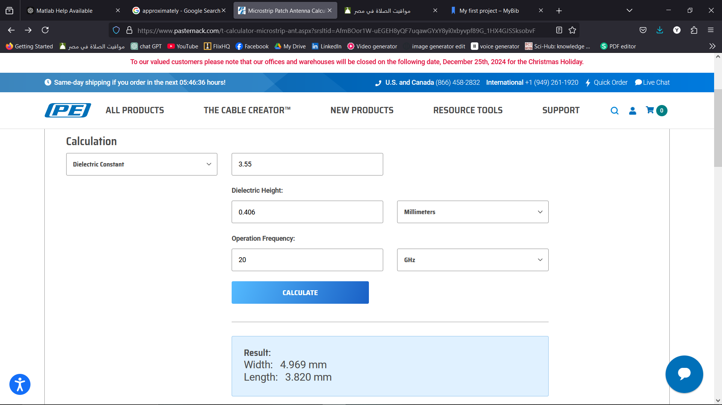We Initialized our design using Pasternack's **Microstrip Patch Antenna Calculator[2]**

Figure 7 EM calculator results

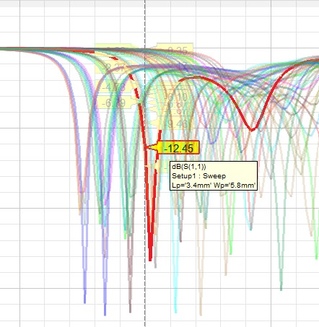In figure 7, we can see that we started with W = 4.969 mm and L = 3.82 mm then we sweapt them to get the specs in figure 8.

Figure 8 L,W S11 sweaping

# Design of single patch

Figure 9: antenna with probe feeding model

Figure 10: 3D patch antenna design

Figure 11: bottom view of patch antenna

Figure 12: side view of patch antenna

And we designed and evaluated these values:  
The substrate length and width is designed so the patch has 3*hs in each side

|  |  |  |  |
| --- | --- | --- | --- |
| Name | Unit | "Evaluated Value" | Description |
| Lp | Mm | 3.633mm | Patch length |
| Wp | Mm | 5.173mm | Patch width |
| hs | Mm | 0.406mm | Substrate height |
| Ws | Mm | 6*hs+Wp=7.609mm | Ground plane width |
| Ls | Mm | 6*hs+Lp=6.475mm | Ground plane length |
| xfeed | Mm | 1.2mm | Feed point x-offset |
| rcoax | Mm | 0.14mm | Coaxial feed radius |
| hcoax | Mm | 0.203mm | Coaxial feed height |
| rprope | Mm | 0.07mm | Probe radius |
| Yfeed | Mm | 0mm | Feed point y-offset |
| Hgnd | Mm | -0.032mm | Ground plane height |

### S11:

For designing single patch antenna, we tuned parameters to get reflection coefficient S11 achieving specs

Figure 13: S11 for single Patch antenna

From figure 11, we succeeded to tuned parameters and achieve minimum s11 at operating frequency 20 GHz =-15.35dB

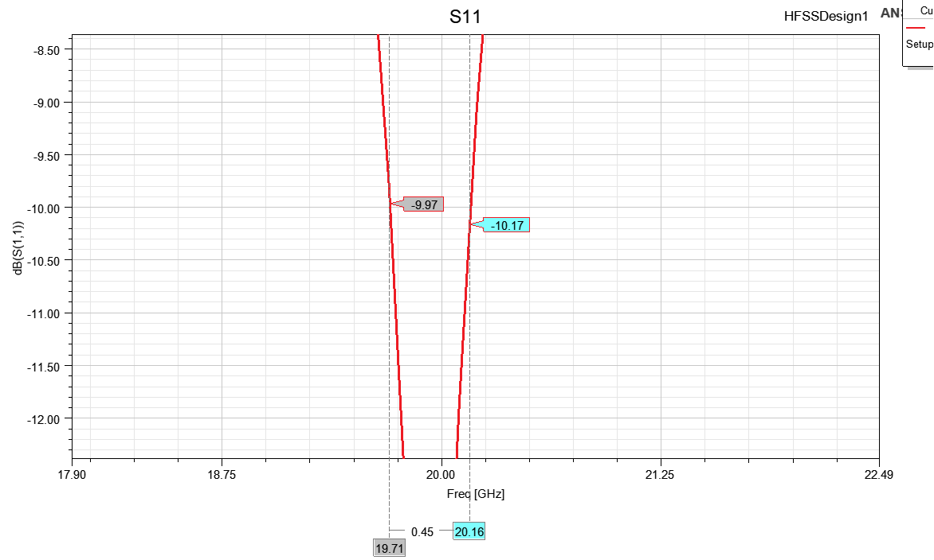,The BW = 450 MHz.

Figure 14: smith chart for single Patch

Figure 15: Bandwidth where S11<-10 dB

As shown in figure 14, Bandwidth achieved for VSWR=1.421

Figure 16: VSWR = 1.421 at 20 GHz for single patch antenna

### Zin:

For proper feeding from the above figure 16, we found that is matching impedance required at 20GHz.

Figure 17 Xfeed for single patch antenna

Figure 18 Zin for single Patch antenna at 20GHz

Figure 19: Yfeed for single patch antenna

From figure 15 and 17, We can see that (x,y) position can change the Zin value.

So we chose (1.2,0) that matched our specs.

### Radiation patterns

Figure 20: Electric Field Radiation for single patch antenna

Figure 21: magnetic field radiation for single patch antenna

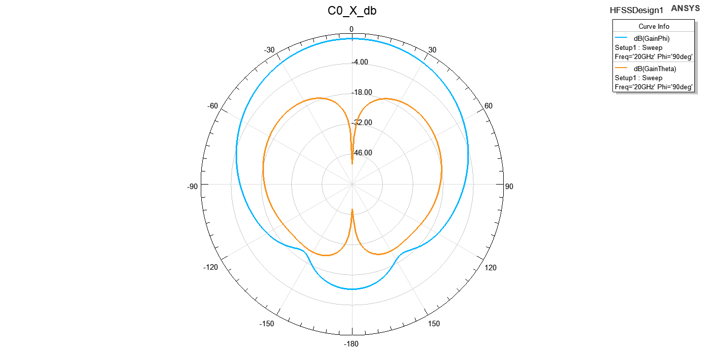

Figure 22: Co-polarization and cross-polarization patterns in the E- and H-planes.

From figure 21 and 22, The radiation pattern of the single patch antenna was observed to exhibit a highly focused, narrow beam, resembling a laser-like projection. This characteristic is attributed to the directive nature of the patch antenna at the operating frequency. Such a pattern indicates a high directivity, which is advantageous for applications requiring concentrated signal transmission or reception in a specific direction.

### Gain:

Figure 23: Gain 3D for single patch antenna

Figure 24: Gain 2D for single patch antenna

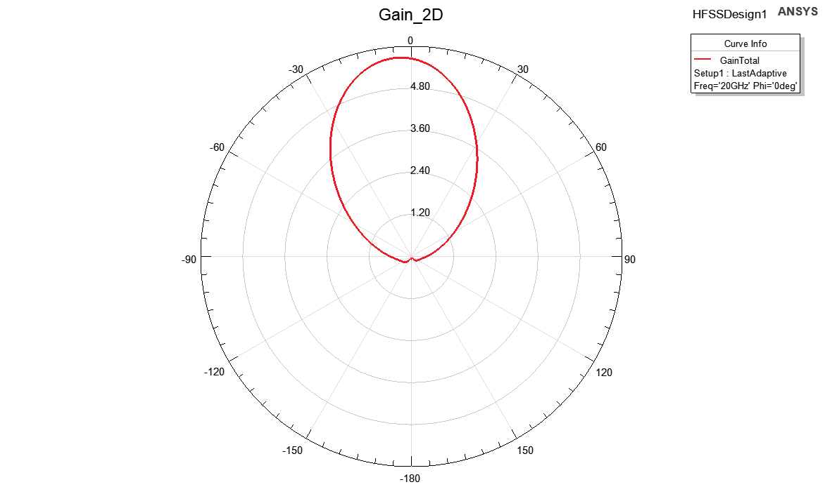

### Gain Performance of a Single Patch Antenna

As shown in figure 23 and 24, The gain of the single patch antenna was measured, and the results showed a single main beam centered at θ=0° with a maximum gain of 5.7dB. This pattern is consistent with the fundamental radiation mode of a microstrip patch antenna, which is typically a broadside radiator designed to focus energy perpendicular to the patch surface.

The observed gain value of 5.7dB is within the expected range for a single patch operating at the designed frequency, accounting for the following factors:

1. **Effective Aperture:** The size and geometry of the patch contribute to its directivity.
2. **Substrate Material:** The dielectric constant and loss tangent of the substrate slightly influence the gain.
3. **Impedance Matching:** Proper matching ensures minimal reflection and maximum radiation efficiency.

This result establishes a baseline for evaluating the performance of the 2-element patch array configuration.

# Design of Two Patches:

We are targeting to design 2 antenna arrays, so we made a replica from our patch and we swept and tuned our parameter to achieve the required specs

Figure 25: Two Patch antenna array

Figure 26: Two Patch side view

We make a sweap on distance between patches (dp) to meet the specs.

The best results was at dp=0.36mm

### S-Parameters:

Also designing two patch antenna array is expected to provide us with higher gain compared to single patch however we noticed that there is a trade off between mutual coupling S21 and achieving required gain:

At first, we tuned parameters to achieve S11 as required

Figure 27: S11 for Two patches

As shown in Figure 27, We have S11 = -10.46 dB< -10 dB at 20 GHz however we faced problems with Bandwidth as it is a very narrow band.

Figure 28: VSWR for first Patch

As shown in Figure 29 and 30, The VSWR1 VSWR2 is equal to 1.63.

Figure 29: VSWR for second Patch

As shown in figure 31, The S21 value equals to -6.52 dB.

Figure 30: S21 Vs Frequency

### Mutual Coupling vs Element Spacing:

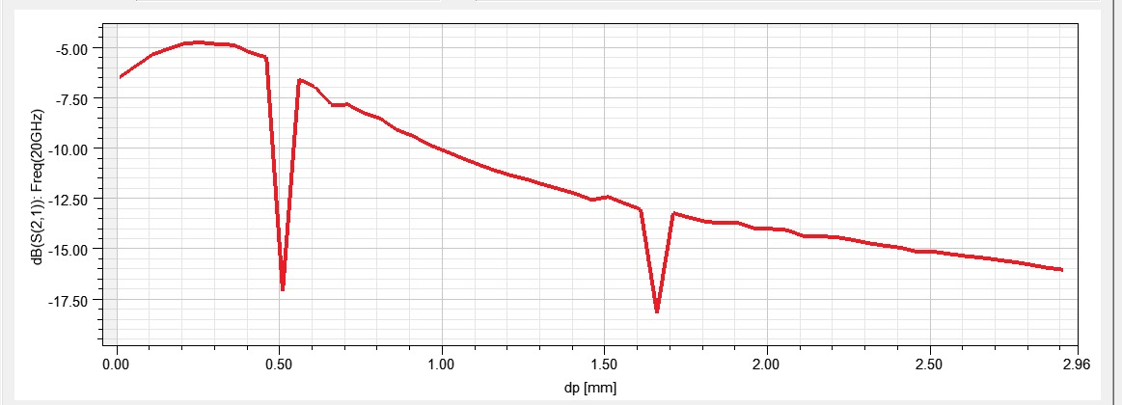as we discussed mutual coupling S21 originated when we add the second patch and we noticed that it varies with distance between two patches (dp) so we made sweep on:

Figure 31: S21 sweep Vs frequency by changing dp

Figure 32: S21 Vs Distance between two patches

As shown in figure 32 and 33:

The relationship between mutual coupling (S21) and element spacing (dp) was analyzed. As expected, S21 exhibited a decaying trend with increasing dp, as the overlapping fields between the antenna elements diminished.

However, two notable deviations were observed:

* At dp=0.5 mm, mutual coupling increased sharply, likely due to strong near-field interactions.
* At dp=1.65mm, S21 dropped to -17.5dB, indicating a resonance condition, possibly caused by constructive interference or standing wave patterns at this specific spacing.

Beyond these points, the coupling returned to the expected decaying trend, consistent with far-field behavior. These observations highlight the importance of precise element spacing in antenna array design to control mutual coupling and optimize performance.

we found that distance between two patches (dp=0.306 mm) to keep S11< -11 dB.

### Zin:

Figure 33: Zin for two Patches at 20 GHz

As shown in figure 28, The Zin equals to 69.05 Ω

We got Zin=69.05 so for proper feeding and enhancing bandwidth.

### A red circle with a number on it Description automatically generated with medium confidenceRadiation patterns

Figure 34: Electric field radiation of two patches

Figure 35: magnetic pattern for two patches

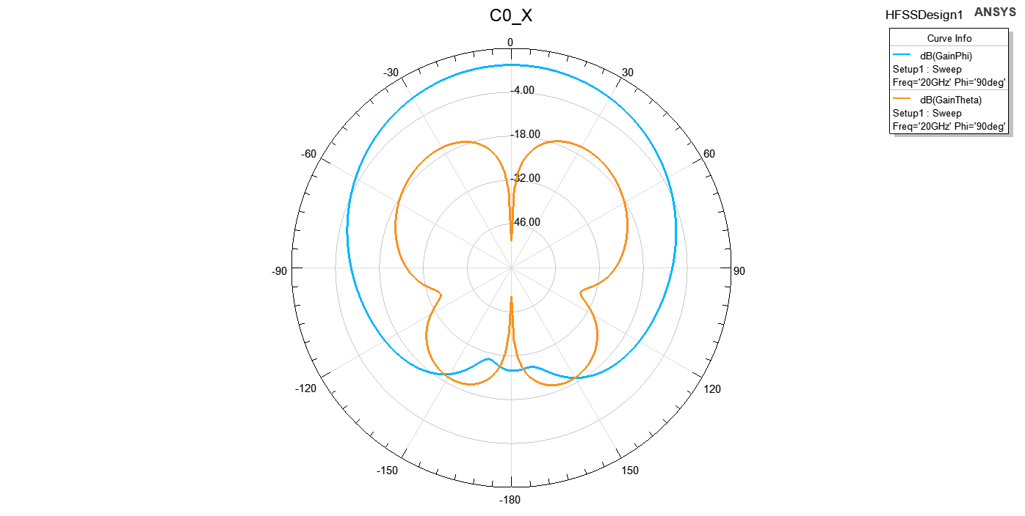As shown in figure 35 and 34, When the two patches were combined into an array, the mutual coupling between the elements and the phase difference between their feeds likely caused the main lobe of the radiation pattern to shift. The offset in the main lobe's direction (centered at θ = -30°) is a typical result of such interactions, where unequal phase distribution or asymmetry in the feed network can steer the beam away from θ = 0°.

Figure 36: Co-polarization and cross-polarization patterns in the E- and H-planes.

### Gain:

Figure 37: Gain 3D for two patches

Figure 38: Gain 2D for two patches

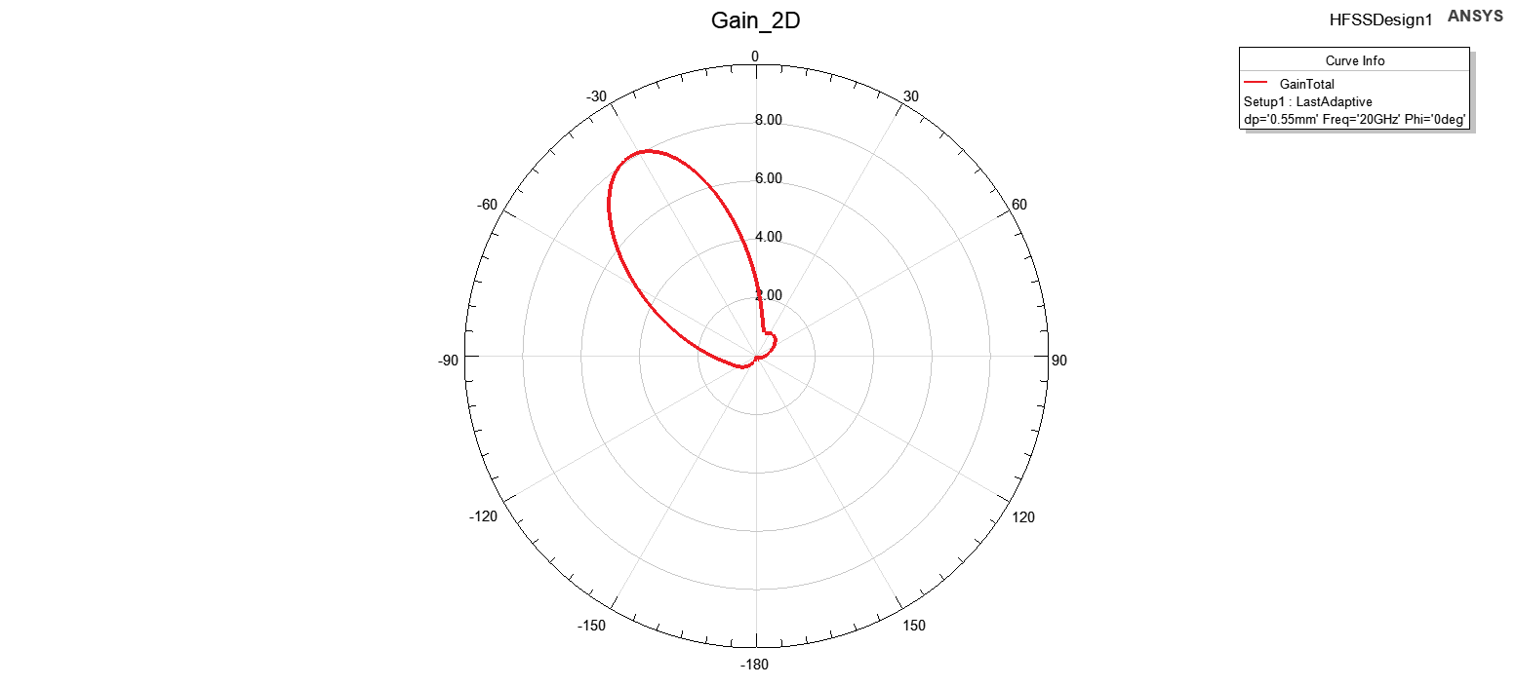

as shown in figure 37 and 38, When the antenna configuration was extended to a **two-patch array**, the gain increased to 8.1dB, demonstrating the expected improvement due to array gain. However, the radiation pattern exhibited an **offset**, with the main beam centered at θ =−30°.

This behavior can be attributed to the following factors:

1. **Element Spacing and Phase Difference:**
   * The mutual coupling and spacing between the two patches likely introduced a phase difference in the radiated fields from each element. This phase offset caused constructive interference to occur at an angle rather than directly broadside (θ=0∘\theta = 0^\circθ=0∘).
2. **Feed Network Asymmetry:**
   * If the feed network introduced a phase imbalance between the two patches, it would steer the beam away from the broadside direction.
3. **Mutual Coupling Effect:**
   * The interaction between the two patches may have modified the effective radiation pattern, pushing the main beam off-center.

This result highlights the importance of ensuring symmetrical feeding and carefully managing element spacing to maintain broadside radiation. Corrective measures, such as tuning the transmission line lengths or adjusting the relative phases, can mitigate this offset.

### Antenna parameters:

Figure 39: Radiation Efficiency Vs Frequency

Figure 40: Gain Vs Frequency

As shown in figure 39 and 40, The plots of **Gain** and **Radiation Efficiency** versus frequency for the two-patch array reveal the following observations:

1. **Maximum Gain and Efficiency:**

* The total gain reaches 9.2dB and radiation efficiency peaks at 9.57dB, but these values are not the global maxima across the frequency range.

1. **Two Distinct Peaks:**

* The gain and efficiency curves exhibit two prominent peaks at approximately **17.5 GHz** and **23.5 GHz**, indicating the frequencies where the array's performance is optimized.
* These peaks could be attributed to **resonances** of the patches, where the radiation is most efficient due to better impedance matching and minimal losses.

1. **Behavior Between Peaks:**

* Between these peaks, the gain and efficiency slightly drop, likely due to suboptimal matching or increased losses in the antenna system.

To maximize performance at a specific operational frequency, the design could be further tuned, such as by adjusting the element spacing, feed network, or patch dimensions. Including this analysis in the report emphasizes the importance of frequency optimization in array design.

# Adding Feeding Network for Two Patch antennas:

Figure 41 Serial TL

## Serial Transmission Line:

As shown in figure 41, We first tried to use the Serial TL with the Two patches with dimensions:

|  |  |  |  |
| --- | --- | --- | --- |
| Name | Unit | "Evaluated Value" | Description |
| LTL_feed | mm | Ls=10.72mm | Feed transmission line length |
| WTL_feed | mm | 0.3mm | Feed transmission line width |

### Results:

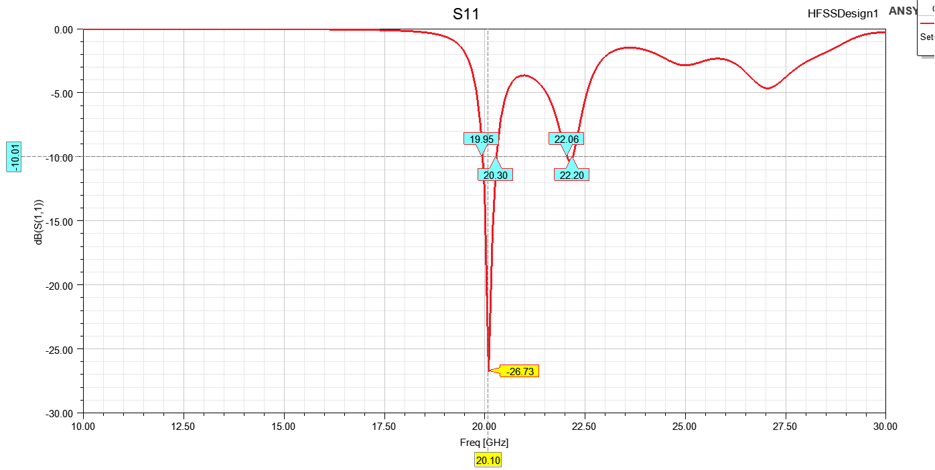

Figure 42 S11 with Serial TL

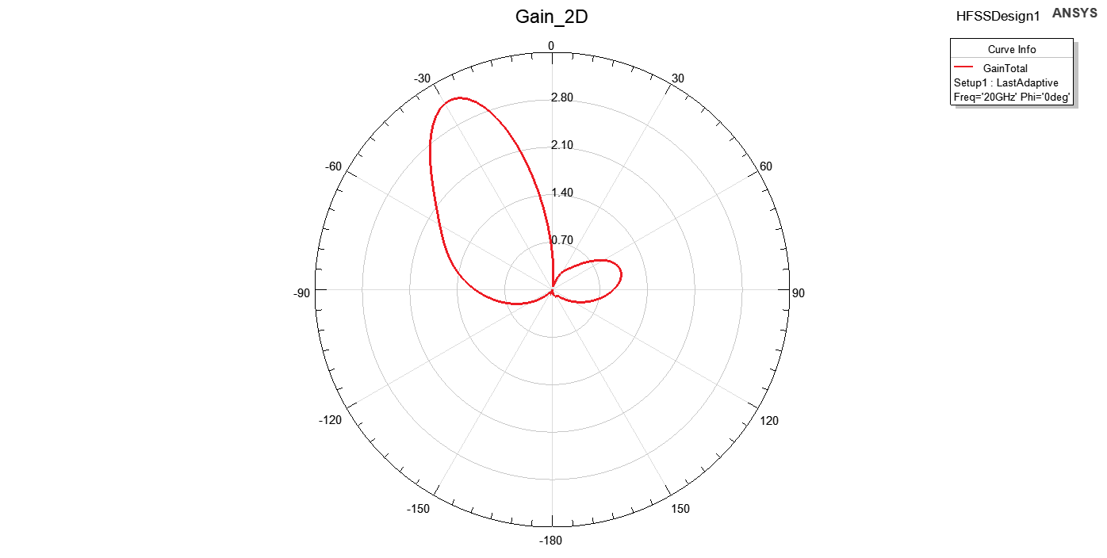As shown in figure 42, The S11 achieved the specs

Figure 43 Gain with Serial TL

As shown in figure 43, The gain was centered at θ =−30°.

The serial transmission line improved impedance matching (S11), but the radiation pattern remained centered at θ = -30° due to phase imbalance between the two patches, caused by unequal path lengths. This imbalance led to constructive interference in the offset direction.

***So we shifted to T-section design***

## T-Section Transmission Line:

Figure 44: T-Section transmission line

As shown in figure 44, We designed a transmission line T-section as shown below and we swept on its dimensions till we achieved requirement.

After Sweaping Here’s the final dimensions:

|  |  |  |  |
| --- | --- | --- | --- |
| Name | Unit | Evaluated Value | Description |
| Lp | mm | 5.78mm | Patch length |
| Wp | mm | 7.54mm | Patch width |
| hs | mm | 0.406mm | Substrate height |
| Ws | - | 11.736mm | Ground plane width |
| Ls | - | 18.206mm | Ground plane length |
| xfeed | mm | 1.1mm | Feed point x-offset |
| dp | mm | 3.5mm | Patch offset parameter |
| rcoax | mm | 0.16mm | Coaxial feed radius |
| hcoax | mm | 0.203mm | Coaxial feed height |
| rprope | mm | 0.07mm | Probe radius |
| yfeed | mm | 0mm | Feed point y-offset |
| hgnd | mm | -0.032mm | Ground plane height |
| Xcoax | - | 2 | Coaxial feed x-offset |
| WTL_In | mm | 0.673367mm | Input transmission line width |
| LTL_feed | mm | 2.179292mm | Feed transmission line length |
| WTL_feed | mm | 0.976256mm | Feed transmission line width |
| LTL_Slot | mm | 0.25mm | Slot length |

### S11:

Figure 45: S11 after adding T-section

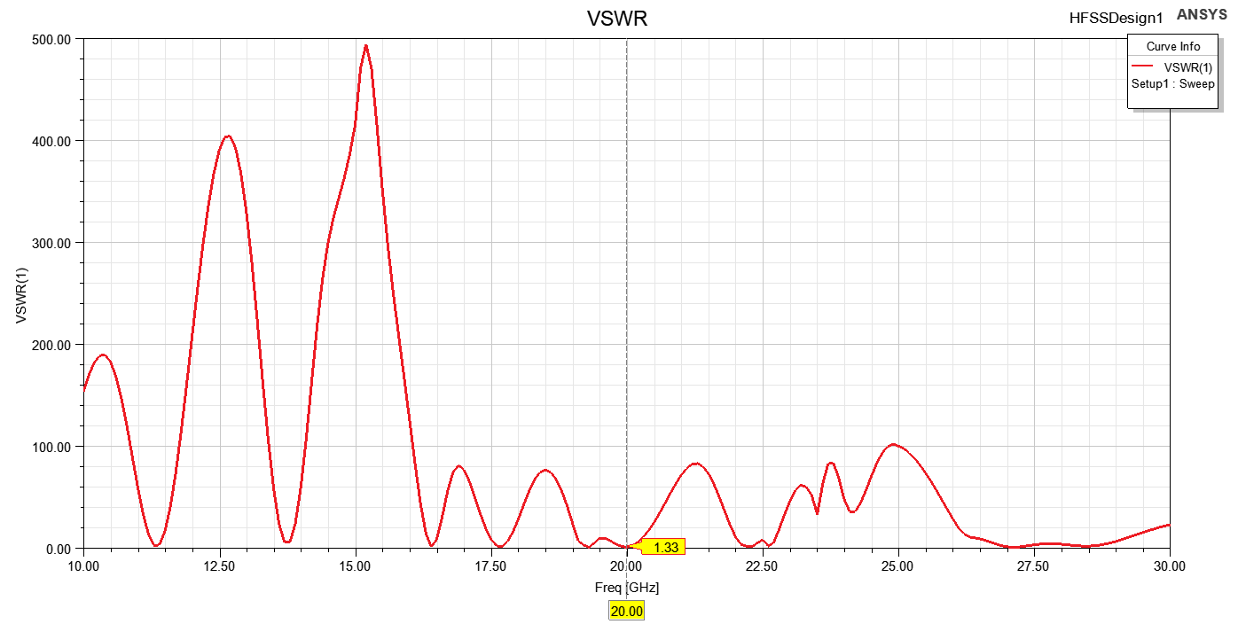From figure 45, we enhanced bandwidth to be more wide from 19.91 GHz to 20.06 GHz with BW= 150MHz.

Figure 47: VSWR after adding feeding network

As shown in figure 47, The VSWR at frequency 20Ghz equals to 1.33.

Figure 46: Zin after adding T-section transmission line

Figure 48: magnetic Field Radiation of 2 antenna design probe feed

Figure 49: Electric Field Radiation of 2 antenna design probe feed

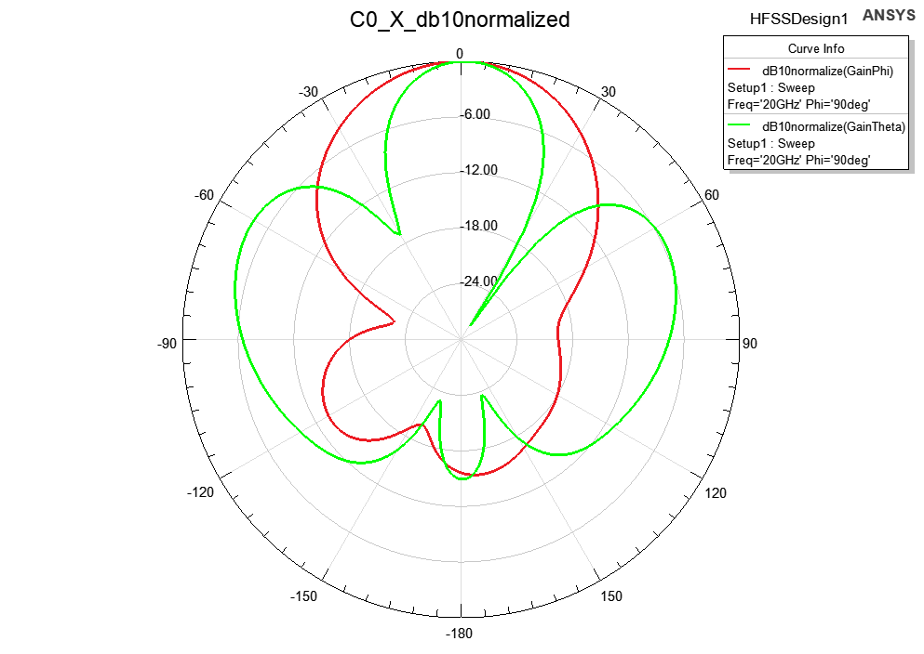

Figure 50: Co-polarization and cross-polarization patterns in the E- and H-planes for 2 antenna array probe feed

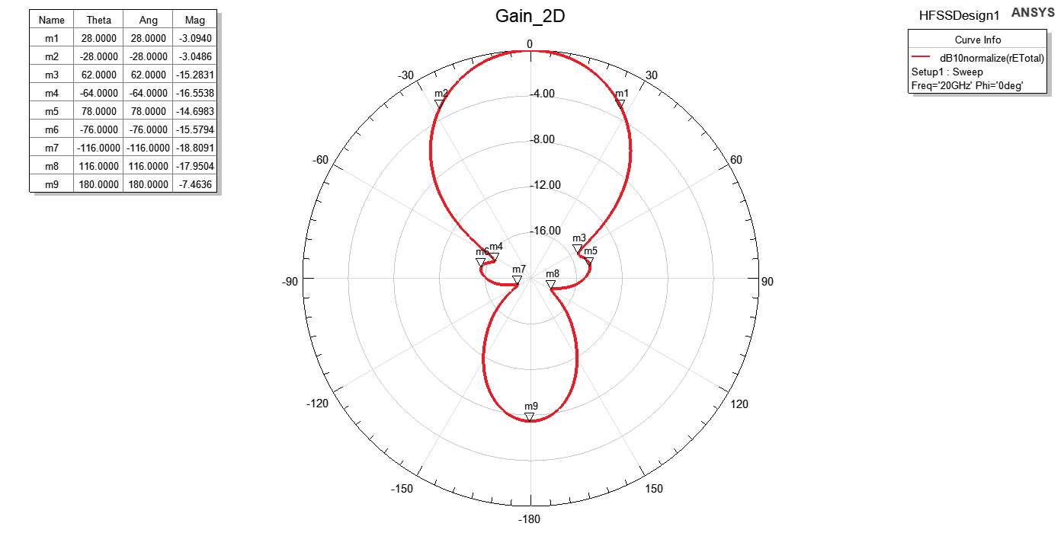

Figure 51: gain 2D for 2 antenna array probe feed

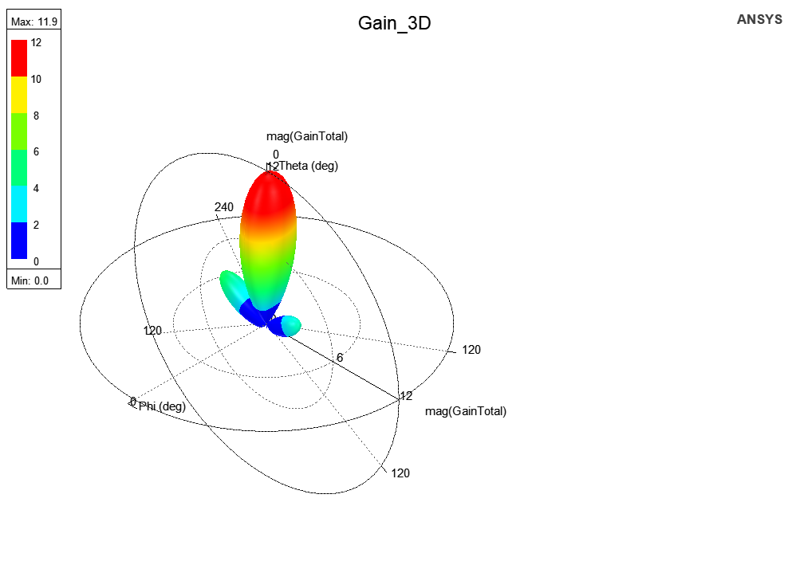

Figure 52: Gain 3D for 2 antenna array probe feed

# 3. Results and Discussion

## 3.1 Return Loss (S11)

* The S11 parameter was evaluated for both the single patch and the 2-element array configurations. The single patch exhibited an S11 below -10 dB at the target frequency of 20 GHz, confirming adequate impedance matching. The 2-element array maintained a similar performance with an optimal patch separation distance of 0.36 mm.
* **Importance of S11 < -10 dB**: Achieving a return loss below -10 dB indicates that at least 90% of the input power is radiated, signifying efficient impedance matching and minimal reflections.

## 3.2 Mutual Coupling (S21)

* Mutual coupling between the patches was studied by sweeping the separation distance (dp). At dp = 0.36 mm, the coupling (S21) was minimized without significantly impacting the radiation characteristics.
* **Element Spacing**: Optimal spacing between array elements is vital to minimize mutual coupling, which can adversely affect radiation patterns and impedance matching. Studies suggest that a separation of approximately half a wavelength is effective in reducing coupling effects.

## 3.3 Smith Chart Analysis

* **Impedance Matching**: The Smith chart provides a visual representation of the antenna's impedance across frequencies. A locus close to the center of the chart at 20 GHz confirms effective matching, which is crucial for maximizing power transfer and minimizing signal reflections.

## 3.4 Radiation Patterns

* The co-polarization and cross-polarization patterns were analyzed in the E and H planes. The results demonstrated a directive radiation pattern with minimal cross-polarization, aligning with design expectations.
* **E-plane and H-plane Patterns**: Analyzing the radiation patterns in both planes reveals the antenna's directivity and beamwidth. A well-designed antenna should exhibit symmetrical patterns with minimal sidelobes, indicating efficient radiation and reduced interference.
* **Cross-Polarization Levels**: Low cross-polarization levels are essential for maintaining signal purity and reducing polarization mismatches, which is particularly important in communication systems to ensure signal integrity.

## 3.5 Gain and Efficiency

* **Impact of Array Configuration**: Transitioning from a single patch to a 2-element array can enhance gain due to constructive interference, but it's essential to manage mutual coupling to prevent efficiency degradation. Proper element spacing and feeding techniques are critical in this regard.

## 3.6 Bandwidth Enhancement Techniques:[3]

* + **Impedance Matching**: Adding a matching network to minimize reflections.
  + **Stacked Patches**: Introducing a second resonant patch above the main patch.
  + **Capacitive Coupling**: Modifying the feed structure to include a capacitive element.
  + **Slotted Patch**: Adding slots to the patch to create additional resonances.

To achieve bandwidth enhancement, we found that the previous techniques are used we started to design our antenna at given resonance frequency 20GHz and we got result for s11,VSWR,Radiation pattern, Gain and directivity, then we found that feeding network is not matched with designed antenna, so we decided to enhance bandwidth using Impedance Matching technique.

# 4. Conclusion

The project successfully designed and analyzed a 2-element probe-fed microstrip patch antenna operating at 20 GHz. The design achieved the desired specifications with S11 below -10 dB, high gain, and radiation efficiency. Mutual coupling and gain vs. element spacing were thoroughly evaluated, and the results provide valuable insights for future antenna designs.

# 6. Refrences:

[1] C. A. Balanis, *Antenna Theory: Analysis and Design*, 4th ed. Hoboken, NJ: Wiley, 2016.

[2] Pasternack.com, 2024, https://www.pasternack.com/ Accessed 27 Dec. 2024.

[3] T. A. Milligan, *Modern Antenna Design*, 2nd ed. Hoboken, NJ, USA: Wiley, 2005, sec. 6-2.

[4] Rogers Corporation, "RT/duroid 5870/5880 high-frequency laminates: Data sheet," Rogers Corporation, Chandler, AZ, USA, 2024. [Online]. Available: <https://www.rogerscorp.com>

[5] R. Garg, P. Bhartia, I. Bahl, and A. Ittipiboon, Microstrip Antenna Design Handbook. Norwood, MA, USA: Artech House, 2001, Sec. 9.2.